National Textile University, Faisalabad


Department of Computer Science
Name | Ghulam Habib
Class | BSSE 3rd
Section | A
Registration No | 24-NTU-CS-FL-1154
Assignment | Lab-1
Course Code | DS-2077
Course Name | Data Structures
Submitted To | Sir Basit
Submission Date | 11-October -2025

DATA STRUCTURES
Lab Plan – 1
Exercise-1:

Following is the declaration of Node class and its member functions. Write the complete definitions of these member functions.

Code :
#include <bits/stdc++.h>
using namespace std;
// class defination
class Node
{
private:
int data;
Node *next;

public:
int getData();
Node *getNext();
void setData(int);
void setNext(Node *);
};
// implementing the class method
// setter
void Node::setData(int data)
{
this->data = data;
}
void Node::setNext(Node *next)
{
this->next = next;
}
// getter
int Node::getData()
{
return this->data;
}
Node *Node::getNext()
{
return this->next;
}
int main()
{
cout << "========setter getter method=======\n";
Node *node1 = new Node();
node1->setData(12);
cout << node1->getData() << endl;
Node *node2 = new Node();
node2->setData(30);
node1->setNext(node2);
cout << "Next Data : " << node1->getNext()->getData();

return 0;
}

Screenshot :
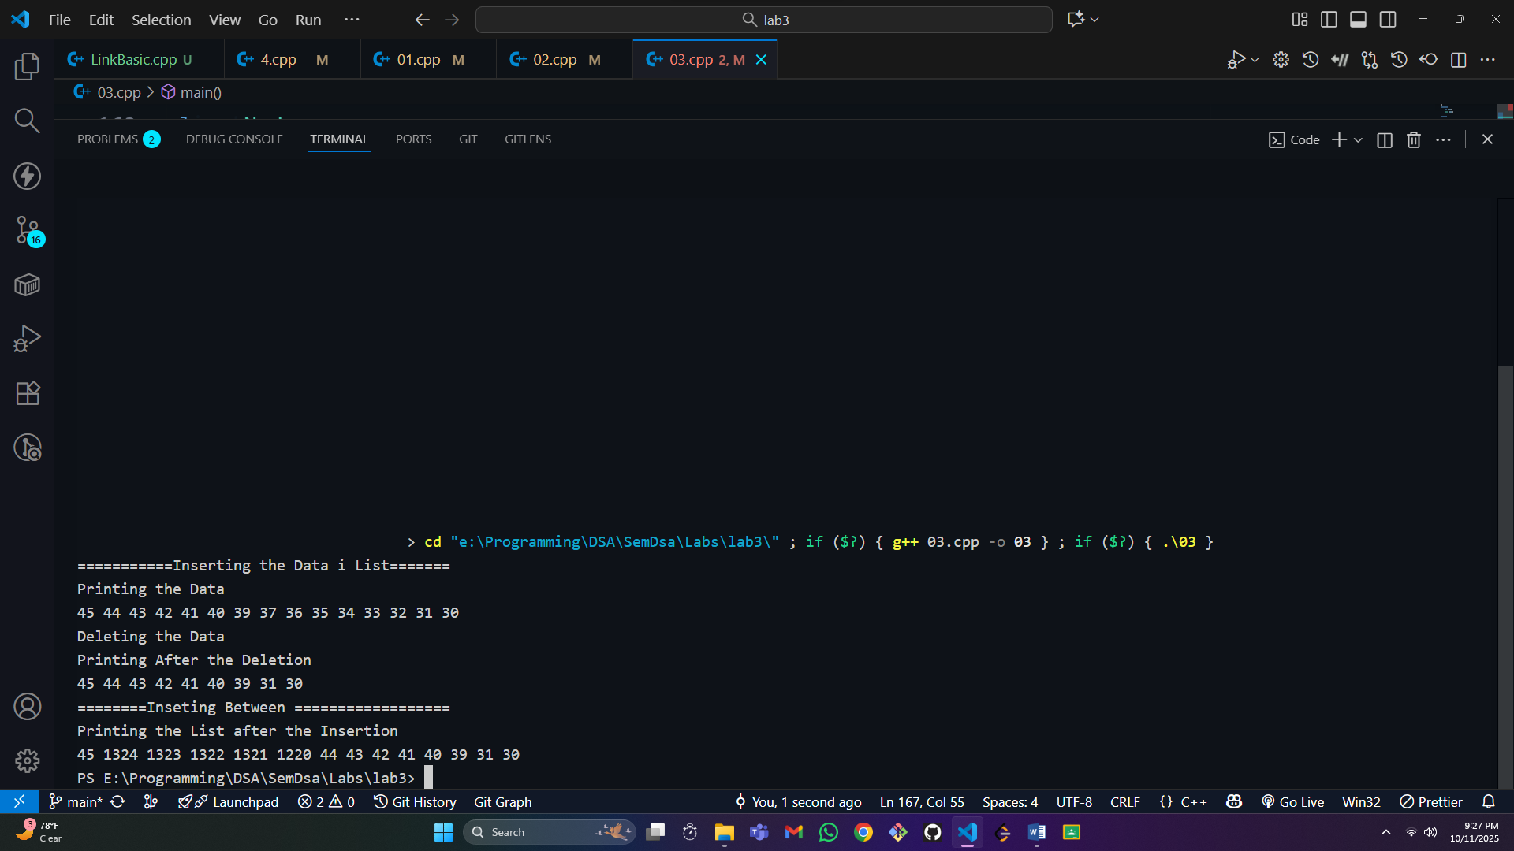

Exercise-2:

Following is the declaration of List class and its member functions. Write the complete definitions of these member functions.

Code :
#include <bits/stdc++.h>
using namespace std;
// class defination
class Node
{
private:
int data;
Node *next;

public:
int getData();
Node *getNext();
void setData(int);
void setNext(Node *);
};
// implementing the class Node method
// setter
void Node::setData(int data)
{
this->data = data;
}
void Node::setNext(Node *next)
{
this->next = next;
}
// getter
int Node::getData()
{
return this->data;
}
Node *Node::getNext()
{
return this->next;
}
class List
{
private:
Node *currentLocation;

public:
List();
void Print();
void Insert(int);
void Delete(int);
void addbetween(int);
};
List::List()
{
this->currentLocation = NULL;
}
void List::addbetween(int data)
{
Node *temp = new Node();
temp->setData(data);
if (currentLocation == NULL)
{
currentLocation = temp;
return;
}
if (currentLocation->getNext() == NULL)
{
currentLocation->setNext(temp);
}
else
{
Node *nexy = currentLocation->getNext();
temp->setNext(nexy);
currentLocation->setNext(temp);
}
}
void List::Insert(int data)
{
Node *temp = new Node();
temp->setData(data);

if (this->currentLocation == NULL)
{
currentLocation = temp;
}
else
{
temp->setNext(this->currentLocation);
currentLocation = temp;
}
}
void List::Print()
{
Node *temp = currentLocation;
while (temp != NULL)
{
cout << temp->getData() << " ";
temp = temp->getNext();
}
cout << endl;
}
void List::Delete(int data)
{
Node *curr = currentLocation;
Node *prev;
bool found = false;
if (currentLocation->getData() == data)
{
Node *temp = currentLocation;
currentLocation = currentLocation->getNext();
return;
}
else
{
while (curr != NULL && !found)
{
if (curr->getData() == data)
{
found = true;
}
else
{
prev = curr;
curr = curr->getNext();
}
}
if (curr == NULL)
{
cout << "Not Presnt In List \n";
}
else
{
if (found)
{
prev->setNext(curr->getNext());
delete curr;
}
}
}
}

int main()
{
cout << "=================Insertion method and Deletion Method===================\n";
List l;
l.Insert(30);
l.Insert(31);
l.Insert(32);
l.Insert(33);
l.Insert(34);
l.Insert(35);
l.Insert(36);
l.Insert(37);
l.Insert(39);
l.Print();
l.Delete(39);
l.addbetween(123);
l.addbetween(1320);
l.Print();
return 0;
}

Screenshot :
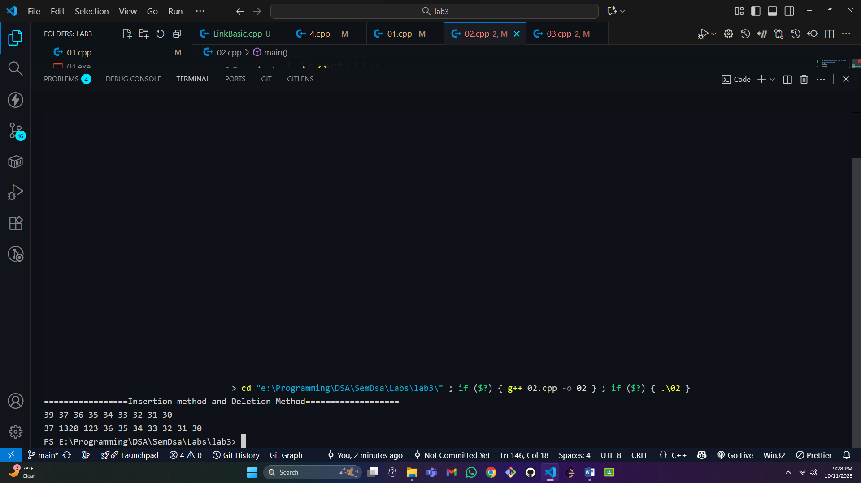

Exercise-3:

Test the code in the main() function by creating Object/s of List class.

Code:
#include <bits/stdc++.h>
using namespace std;
// class defination
class Node
{
private:
int data;
Node *next;

public:
int getData();
Node *getNext();
void setData(int);
void setNext(Node *);
};
// implementing the class Node method
// setter
void Node::setData(int data)
{
this->data = data;
}
void Node::setNext(Node *next)
{
this->next = next;
}
// getter
int Node::getData()
{
return this->data;
}
Node *Node::getNext()
{
return this->next;
}
class List
{
private:
Node *currentLocation;

public:
List();
void Print();
void Insert(int);
void Delete(int);
void addbetween(int);
};
List::List()
{
this->currentLocation = NULL;
}
void List::addbetween(int data)
{
Node *temp = new Node();
temp->setData(data);
if (currentLocation == NULL)
{
currentLocation = temp;
return;
}
if (currentLocation->getNext() == NULL)
{
currentLocation->setNext(temp);
}
else
{
Node *nexy = currentLocation->getNext();
temp->setNext(nexy);
currentLocation->setNext(temp);
}
}
void List::Insert(int data)
{
Node *temp = new Node();
temp->setData(data);

if (this->currentLocation == NULL)
{
currentLocation = temp;
}
else
{
temp->setNext(this->currentLocation);
currentLocation = temp;
}
}
void List::Print()
{
Node *temp = currentLocation;
while (temp != NULL)
{
cout << temp->getData() << " ";
temp = temp->getNext();
}
cout << endl;
}
void List::Delete(int data)
{
Node *curr = currentLocation;
Node *prev;
bool found = false;
if (currentLocation->getData() == data)
{
Node *temp = currentLocation;
currentLocation = currentLocation->getNext();
return;
}
else
{
while (curr != NULL && !found)
{
if (curr->getData() == data)
{
found = true;
}
else
{
prev = curr;
curr = curr->getNext();
}
}
if (curr == NULL)
{
cout << "Not Presnt In List \n";
}
else
{
if (found)
{
prev->setNext(curr->getNext());
delete curr;
}
}
}
}

int main()
{
List l;
cout << "===========Inserting the Data i List======= \n";
l.Insert(30);
l.Insert(31);
l.Insert(32);
l.Insert(33);
l.Insert(34);
l.Insert(35);
l.Insert(36);
l.Insert(37);
l.Insert(39);
l.Insert(40);
l.Insert(41);
l.Insert(42);
l.Insert(43);
l.Insert(44);
l.Insert(45);

cout << "Printing the Data \n";
l.Print();
cout << "Deleting the Data \n";
l.Delete(32);
l.Delete(33);
l.Delete(34);
l.Delete(35);
l.Delete(36);
l.Delete(37);
cout<<"Printing After the Deletion \n";
l.Print();
cout<<"========Inseting Between ==================\n";
l.addbetween(1220);
l.addbetween(1321);
l.addbetween(1322);
l.addbetween(1323);
l.addbetween(1324);
cout<<"Printing the List after the Insertion \n";
l.Print();

return 0;
}

Screenshot :
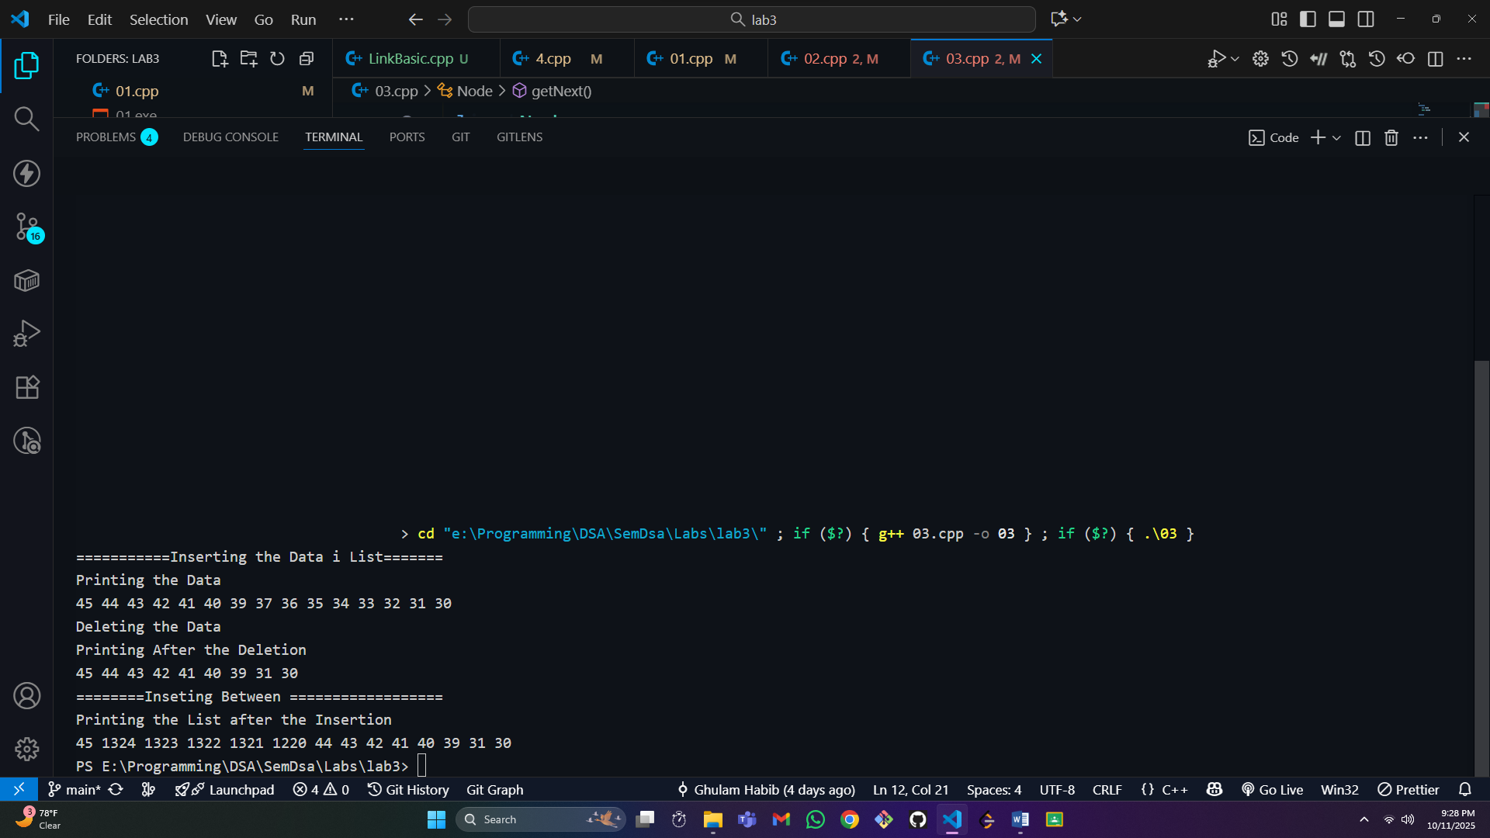

Exercise-4:

Implement the following functions on single link list

a. Finding Minimum

b. Finding Maximum

c. Searching

d. Inserting Item at desired location (take location from user)

e. Swapping two elements in the linked list

f. Inserting an element in sorted list g. Sorting the list

Code :
#include <iostream>
using namespace std;
class node
{
int data;
node *next;

public:
int getData();
node *getNext();
void setData(int data);
void setNext(node *next);
};
void node::setData(int data)
{
this->data = data;
}
void node::setNext(node *next)
{
this->next = next;
}
int node::getData()
{
return this->data;
}
node *node::getNext()
{
return next;
}
class LinkList
{
node *first;

public:
LinkList();
void insertFirst(int data);
void sortList();
void print();
void swap(int data, int data2);
bool search(int data);
void insertInsortedList(int data);
};
void LinkList::insertInsortedList(int data)
{
sortList();
node *prev;
node *curr = first;
node *newnode = new node();
bool found = false;
newnode->setData(data);
if (first == NULL)
{
first = newnode;
}
else
{
if (data < first->getData())
{
newnode->setNext(first);
first = newnode;
}
else
{
while (curr != NULL && !found)
{
if (curr->getData() >= data)
{
found = true;
}
else
{
prev = curr;
curr = curr->getNext();
}
}
if (found)
{
prev->setNext(newnode);
newnode->setNext(curr);
}
}
}
}
void LinkList::swap(int data1, int data2)
{
bool firstFound = search(data1);
bool secondFound = search(data2);
if (firstFound && secondFound)
{
node *temp = first;
node *nexty = first->getNext();
while (temp != NULL)
{
if (data1 == temp->getData())
{
break;
}
else
{
temp = temp->getNext();
}
}
while (nexty != NULL)
{
if (data2 == nexty->getData())
{
break;
}
else
{
nexty = nexty->getNext();
}
}
nexty->setData(data1);
temp->setData(data2);
return;
}
else
{
cout << "Data is Not present in list\n";
}
}
bool LinkList::search(int data)
{
if (first == NULL)
{
return false;
}
if (data == first->getData())
{
return true;
}
node *temp = first;
bool found = false;
while (temp != NULL && !found)
{
if (temp->getData() == data)
{
found = true;
}
else
{
temp = temp->getNext();
}
}
return found;
}
void LinkList::sortList()
{
if (first == NULL || first->getNext() == NULL)
{
return;
}

node *temp = this->first;
while (temp != NULL)
{
node *prev = first;
node *nexy = first->getNext();
while (nexy != NULL)
{
if (prev->getData() > nexy->getData())
{
int temp = prev->getData();
int nexyTemp = nexy->getData();
nexy->setData(temp);
prev->setData(nexyTemp);
prev = nexy;
nexy = nexy->getNext();
}
else
{
prev = nexy;
nexy = nexy->getNext();
}
}
temp = temp->getNext();
}
}
LinkList::LinkList()
{
this->first = NULL;
}
void LinkList::insertFirst(int data)
{
node *temp = new node();
temp->setData(data);
if (this->first == NULL)
{
first = temp;
}
else
{
temp->setNext(this->first);
first = temp;
}
}
void LinkList::print()
{
node *temp = first;
while (temp != NULL)
{
cout << temp->getData() << " ";
temp = temp->getNext();
}
cout << endl;
}
int main()
{
LinkList listy;
listy.insertFirst(10);
listy.insertFirst(20);
listy.insertFirst(30);
listy.insertFirst(40);
listy.insertFirst(50);
cout<<"==============Unsortd List================ \n";
listy.print();
cout<<"==================Sorted List============== \n";
listy.sortList();
listy.print();
cout<<"===================Swap funtion================ \n";
listy.swap(10, 50);
listy.print();
cout << "==================Printing after swap ===============\n";
listy.sortList();
listy.print();
cout<<"================Inserting value in sorled list ===================\n";
listy.insertInsortedList(40);
listy.print();

return 0;
}

ScreenShot :
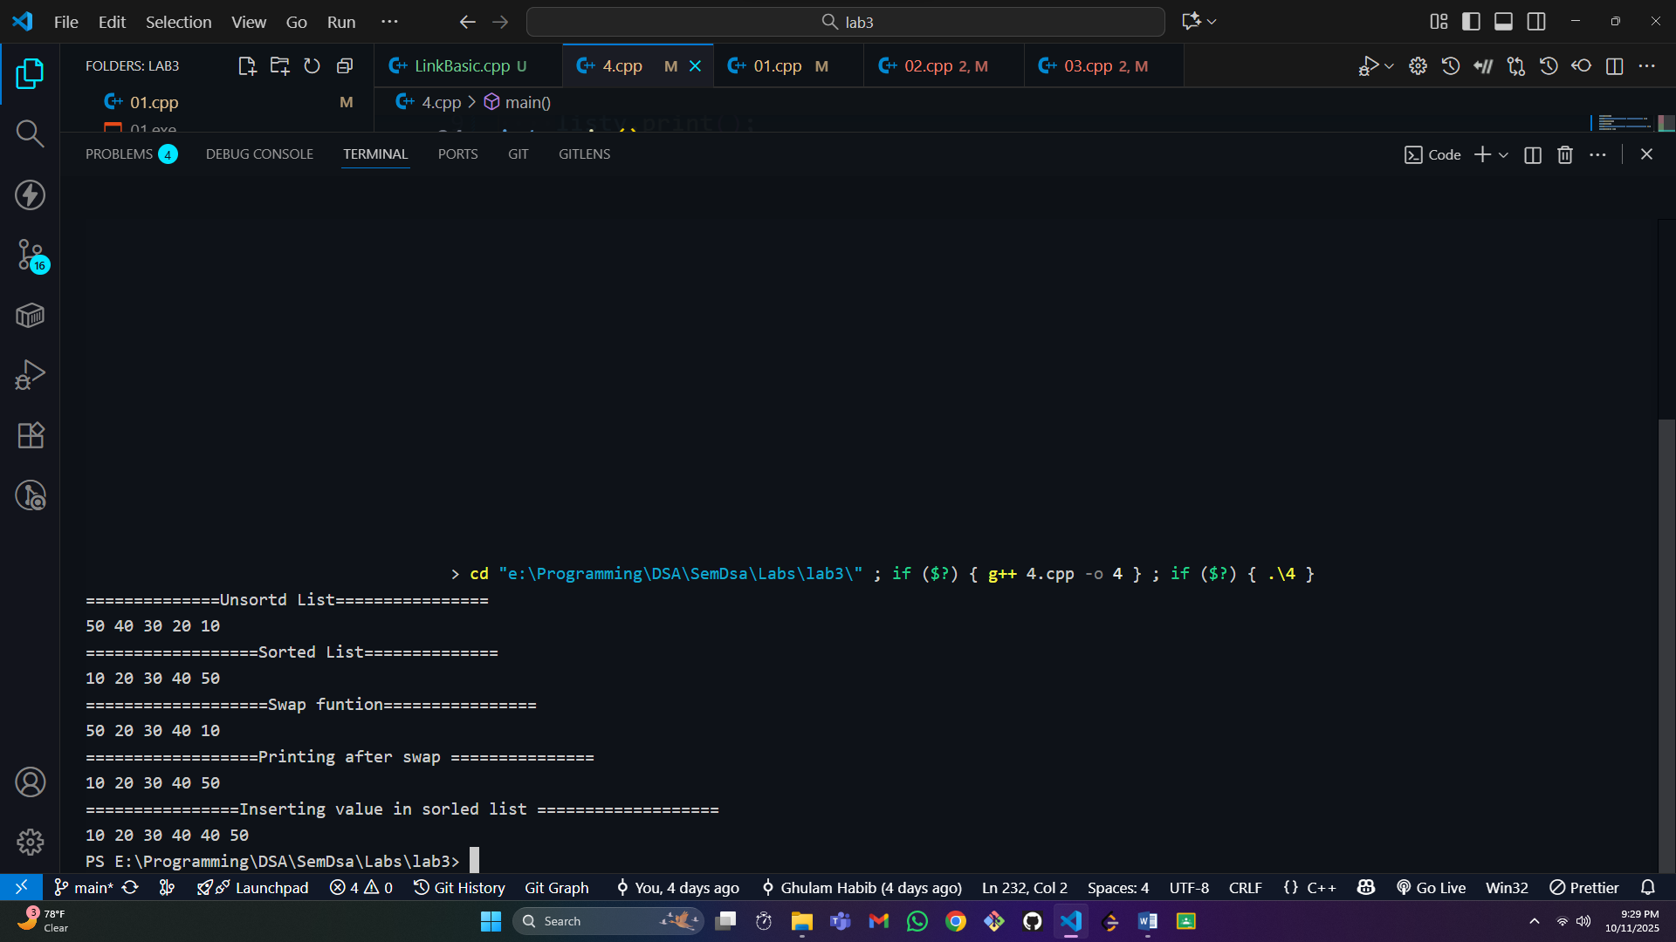

===========End==============

